BEGINNING OF TERM ONE EXAMINATION 2024
PRIMARY TWO
ENGLISH

My name is ________________________________________________
Class ______________________________________________________

1. Fill in the missing letters.
(a) s__hool (b) bic__cle

2. Name these things we make.
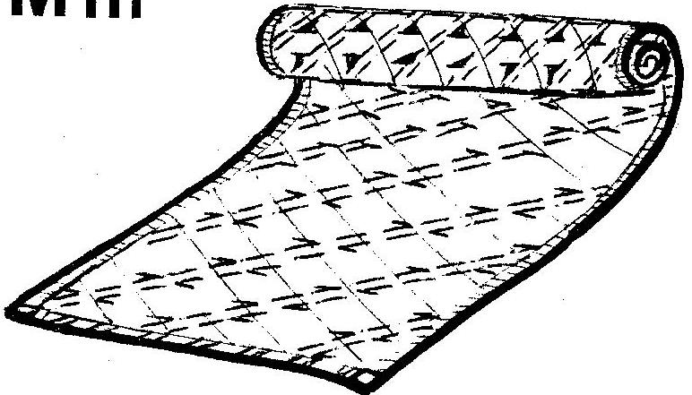 | 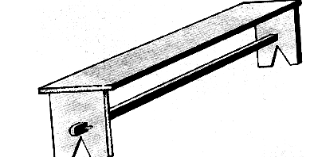

3. Arrange the words in a, b, c order.
(a) clock desk book axe
_____________________________________________
(b) girl fish hen elephant _______________________________________________

4. Fill in ‘a’ or ‘an’
(a) Sarah ate _________ mango and _________ apple.

(b) I made ________ mistake in my work.
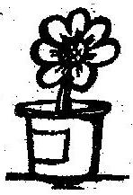
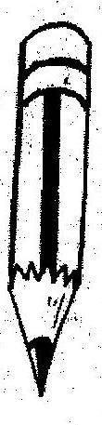
5. Fill in the correct word.
(a) The pencil is ______________ the tin.

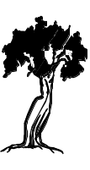
(b) That is a _____________.

6. Write these words in small letters.
(a) TRAIN ______________________________
(b) FERRY ______________________________

7. Write a short word from the long word.
- weather _____________
- train ________________

8. Complete these sentences correctly.
(a) Chair is to chairs as tree is to _______________
(b) Knife is to knives as leaf is to _______________

9. Put a correct punctuation mark.
(a) How old are you
(b) Here is Marys book.

10. Tick the odd one out.
(a) pig, cow, hen, goat
(b) table, tent, kiosk, flat
11. Use the correct form of the verb in brackets.
(a) They are ________________ in the hall. (dance)
(b) We _________________ our homework yesterday. (do)
(c) Thomas _______________ to school everyday. (go)

12. Complete the table below.
 | Male | Female
(a) | cock | ________________
(b) | _______________ | girl
(c) | lion | ________________

13. Fill in the correct word from the bracket.
(a) ______________ are the books. (Hear, Here)
(b) Teacher ________________ my name. (knows, nose)
(c) The man has one ________________. (sun, son)

14. Complete the given sentences with a correct word from the box.
heap pair flock bread

- Mother bought a loaf of ________________________.
- It is a big __________________ of sand.
- A ________________ of sheep is crossing the road.
15. Join as instructed in the brackets.
(a) Mary has a bag. Mary has a pen.
(Join using: …...and……)
___________________________________________________
(b) We went to the zoo. We did not see the lion.
(Join using: ..….but…....)
___________________________________________________
(c) Kato is not playing. Kato is sick.
(Join using: …….because……..)
__________________________________________________

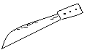
16. Match a word to the correct picture.
 (a) knives
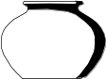
(b) pots
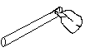
(c) hoes
17. Write three correct sentences from the table.
The teachers  She  You always | do  does | her work neatly.  their homework daily.  good work.

(a) _______________________________________________________
(b) _____________________________________________________
(c) _______________________________________________________
18. Write a word similar to the underlined one.
(long, ill, money, correct)
(a) My uncle gave me cash. __________________
(b) Our teacher is very sick. _________________
(c) All my answers are right. _________________

19. Complete the table correctly.
short | shorter | shortest
long | ________________ | longest
_______________ | bigger | biggest
tall | taller | __________________

20. Write the short form of these words.
(a) Saturday _____________________
(b) October _____________________
(c) is not _____________________

Good Luck.
Marking guide for P2 English
B.O .TERM ONE 2024
- (a) c (b) y
- Basket chair
- (a) axe, book, clock, desk
(b) elephant, fish, girl, hen
- (a) a (b) an (c) a
- (a) on (b) near
- (a) train (b) ferry
- (a) eat/her (b) in
- (a) trees (b) leaves
- (a) How old are you?
(b) Here is Mary’s book.
- (a) hen (b) table
- (a) dancing (b) did (c) went
- (a) hen (b) boy (c) lioness
- (a) Here (b) knows (c) son
- (a) bread (b) heap (c) flock
- (a) Mary has a bag and a pen.
(b) We went to the zoo but we did not see the lion.
(c) Kato is not playing because he is sick.
16. (a) knives
(b) pots
(c) hoes
17. (a) The teachers do good work.
(b) She does her work neatly.
© You always do good work.
- The teachers do their work daily.
18. (a) money (b) ill (c) correct
19. longer, big, tallest
20. (a) Sat (b) Oct. (c) Isn’t

